FEC7: INTRODUCTION TO ENVIRONMENTAL SCIENCES

**ALL ABOUT ECOSYSTEMS**

ADITYA SINGH 2K19/EP/005

horizontal line

# 

# Introduction

The simplest definition of an ecosystem is that it is a community or group of living organisms that live in and interact with each other in a specific environment.

For instance, tropical forests are ecosystems made up of living beings such as trees, plants, animals, insects and microorganisms that are in constant interaction between themselves and that are affected by other physical (sun, temperature) or chemical (oxygen or nutrients) components.

# DEFINITION



An ecosystem is the basic unit of the field of the scientific study of nature. According to this discipline, an ecosystem is a physically defined environment, made up of two inseparable components:

* The biotope (abiotic): a particular physical environment with specific physical characteristics such as the climate, temperature, humidity, concentration of nutrients or pH.
* The biocenosis (biotic): a set of living organisms such as animals, plants or microorganisms, that are in constant interaction and are, therefore, in a situation of interdependence.

The concept of < ecosystem > is possible at several scales of magnitude. From multicellular organisms such as insects, animals or plants to lakes, mountain ranges or forests to the planet Earth as a whole.

## How Do Natural Ecosystems Work?

Natural ecosystems are “balanced” systems. This means the interactions between the different organisms that make up the ecosystem contribute to a certain stability. For example, in grassland ecosystems, herbivores consume grass, but also feed the soil with their droppings, which allows the grass to grow back and allows some sort of balance. Still, this doesn’t mean an ecosystem, even a healthy one, is static. In reality, ecosystems are constantly evolving as they are based on dynamic processes that are constantly changing.

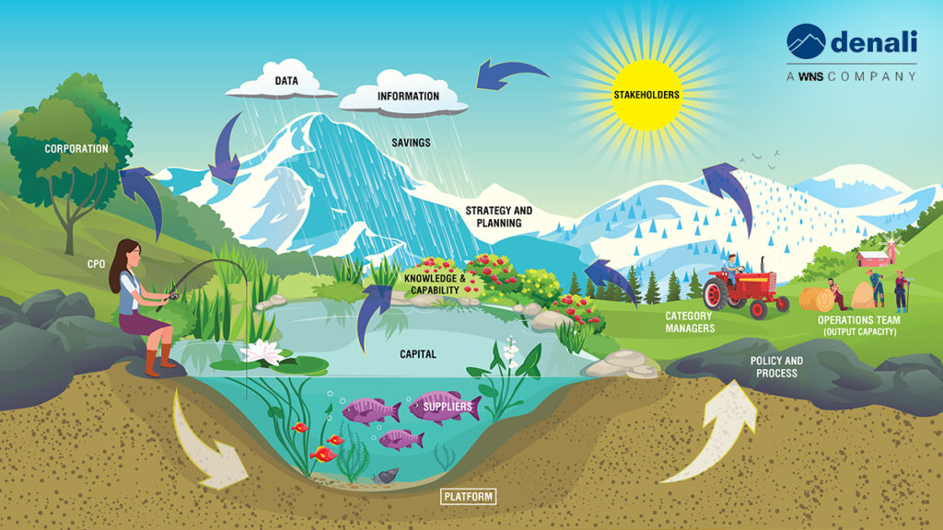

For instance, biocenosis are living organisms that interact with their environment and constantly transform it. How? Because animals compact the soil, plants create humidity or regulate the temperature and bacteria help in the microscopic world by protecting all sorts of animals from diseases and helping in their digestion process. As well, an ecosystem also evolves due to external or unforeseen events. A climatic or natural phenomenon, for example, can lead to transformations in the environment. In this way, biocenosis the ecosystem’s living organisms adapt to these new constraints, and change happens.

It’s also curious that although an ecosystem is always looking for stability, the ecosystem never perfectly succeeds at it. The various natural imbalances tend to offset each other permanently. Some ecosystems evolve very slowly while others can transform very quickly. Sometimes, in extreme cases, they can even disappear.

## Ecosystems And Human Activities

We’ve managed to control fire, practice agriculture, and build transportation vehicles. We’ve built factories, dams, solar panels and we’re constantly finding new ways of exploring space. Still, the human race’s thirst to use, modify and transform natural ecosystems seems endless. For instance, when we transform a plain to grow cereal fields, we’re significantly modifying that local ecosystem. Sometimes, we even end up completely changing it from its original foundations.

Today, human activities have such an impact on ecosystems that we now speak of the Anthropocene timeline. This is a period that defines the significant human impact of human activities on the Earth’s atmospheric, biospheric, geologic and hydrologic systems. This period in time also considers changes happening due to climate change events, which is also mainly caused by human activities. We can see all these changes everywhere. When trees are taken down in the Amazonian forest, the ecosystems change as species struggle to survive and the local humidity and the climate both change. As well, building a dam also changes the distribution of water and affects the species living along the river’s course.

## Why Is Preserving Ecosystems Important?

Like all other living beings, humans are dependent on natural ecosystem services to survive. We need it to get the food we eat, the water we drink and to transform raw materials into our everyday products. So in order to keep our living conditions, it’s truly important that we preserve natural ecosystems.

For example, the agriculture that provides our food depends on the characteristics of a specific ecosystem. Cereals or vegetables grow only under certain conditions of temperature and humidity. They also need certain natural processes, such as pollination, to take place. If we change these characteristics too intensely, there is the risk that we aren’t able to produce what we produce today, or at least not in the same way. That’s why there are some agricultural techniques that understand and manage food production (such as agroforestry, permaculture or regenerative agriculture) that have the wider impacts of using herbicides, pesticides, exhausting nearby water sources or betting on different types of trees that make ecosystems more resilient.

## What Are The Ecosystem Services?

According to FAO, ecosystem services, worth USD $125 trillion, “make human life possible by, for instance, providing nutritious food and clean water, regulating disease and climate, supporting the pollination of crops and soil formation, and providing recreational, cultural and spiritual benefits.”

For all these to be possible, Earth’s ecosystems like forest ecosystems, grassland ecosystems, aquatic ecosystems or agroecosystems need to properly function. But the fact is that some ecosystem services are currently under threat.

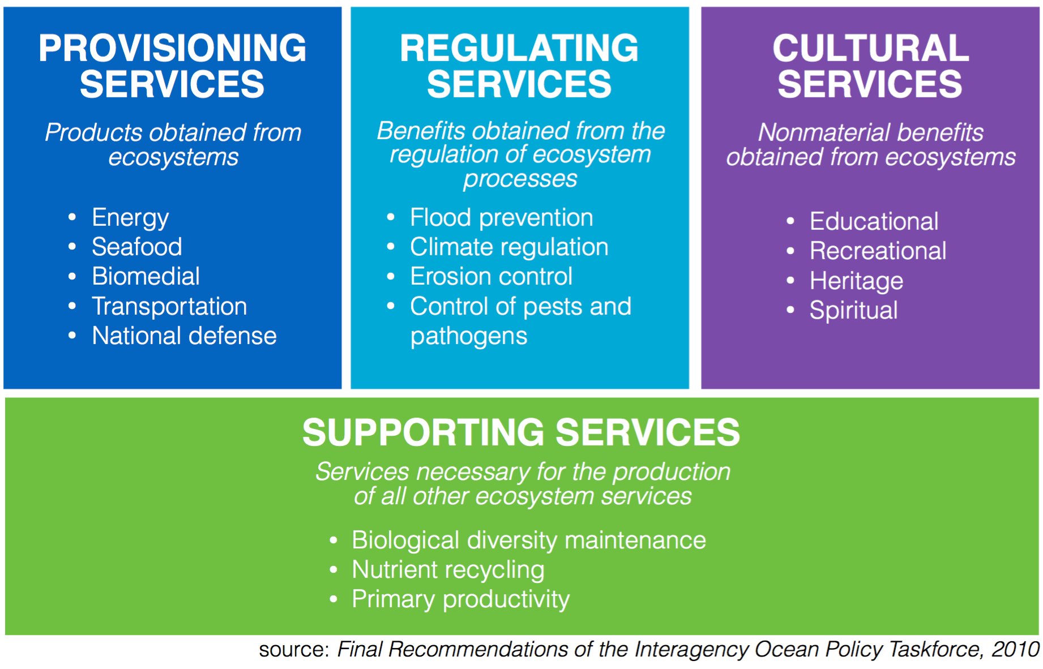

## Ecosystem Services: Examples

Without ecosystem services, life on Earth as we know it wouldn’t exist. There are four main categories of ecosystem services:

Provisioning services refer to the products secured by ecosystems. These include:

• Water

• Food (including cattle and seafood)

• Pharmaceuticals, biochemicals, and industrial products

• Energy (sunlight, hydropower, biomass)

Regulating services are the ecosystem services that allow the regulation of ecosystem processes such as:

• Climate regulation (and carbon absorption and storage via the oceans, trees, soil)

• Waste decomposition (one of the most essential microbial process happening in soil)

• Crop pollination (performed by agents such as bees that contribute to the reproduction of flowering plants)

• Water and air purification and regulation

• Control of pests and diseases

Supporting and habitat services refer to the ability of ecosystems to give habitat for migratory species and to support the viability of gene-pools.This is possible thanks to:

• Primary reproduction

• Nutrient and seed dispersal

Cultural services are the benefits ecosystem services bring to humans. Examples of these are:

• Inspiration for intellectual (creativity), cultural (entertainment) and spiritual (why) purposes

– Remember how it feels good to seeing and hearing wild birds

– Animals, plants and even the funghi kingdom serve as inspiration in theaters, movies…

– Many people go to natural sites when they want to be alone or reflect about life

• Recreational experiences such as outdoors activities or ecotourism

• Scientific discovery and optimization/efficiency by following examples of the natural world (biomimicry)

**END**